**Capstone Project**

**Applied Data Science Capstone by IBM/Coursera**

Kim, Jaekyeong

**Table of contents**

1. Introduction: Business Problem

2, Data

3. Methodology

4. Analysis

5. Results and Discussion

6. Conclusion

**Introduction : Business Problem**  
In this project we will try to find an optimal location for hotel for foreigners.

This project is targeting foreigners who come to Korea for purposes whether traveling or on their business. In Korea, many people use hotel when they visit other countries even in their visit to the other Korea regions. Most of hotels used to marketing their facilities and public transportation that is accessible from where they are.

We will assume that we are trying to make hotel and looking for the optimal location for our hotel density. We are targeting foreigners who visit Korea, Seoul. So, our candidates will be the location near Seoul and I will consider hotels only in Seoul.

**Data**

To solve our Business Problem we need to figure out the factors below

- number and location of hotels clusters near Seoul

We will use 'Google Maps API geocoding' and 'Foursquare API' to get locations and categories of the hotels.

Get coordination data of KAIST from Google Maps API.

Draw map using folium and coordination data.

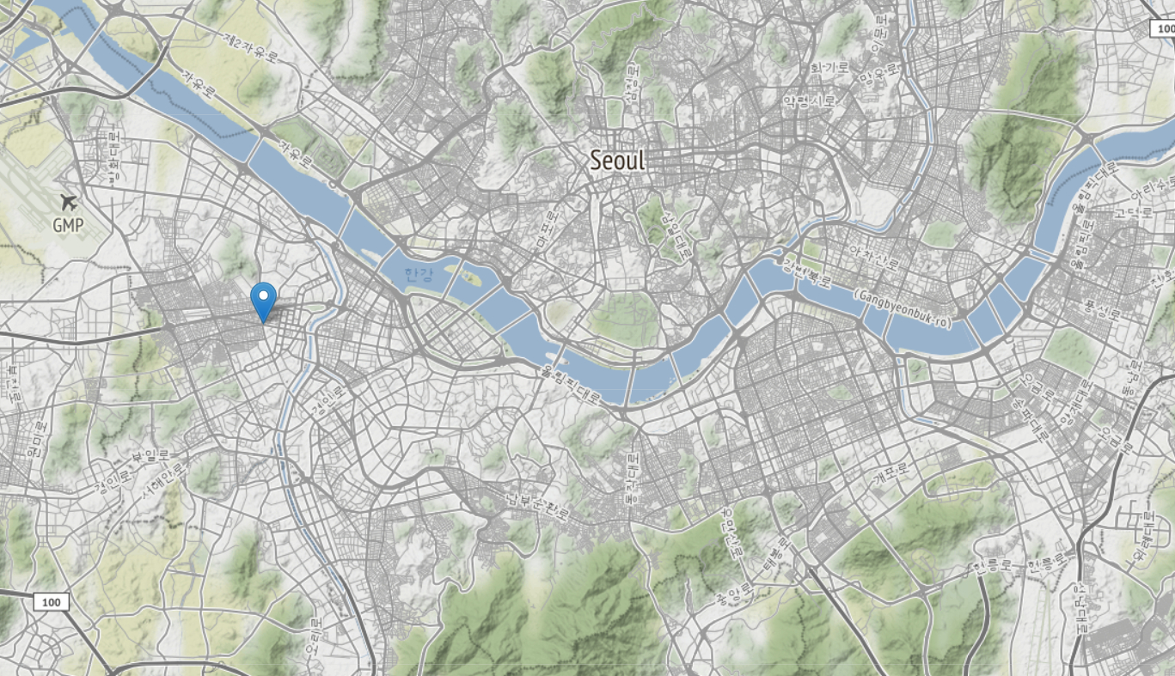

And then hotel data from Foursquare. and label each hotels name.

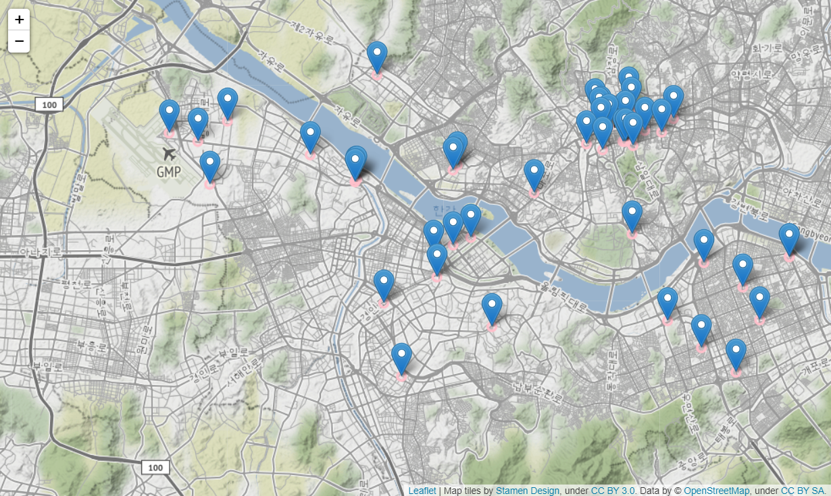

We will use 'Google Maps API geocoding' and 'Foursquare API' to get locations and categories of the restaurants.

Get coordination data of KAIST from Google Maps API.

Draw map using folium and coordination data.

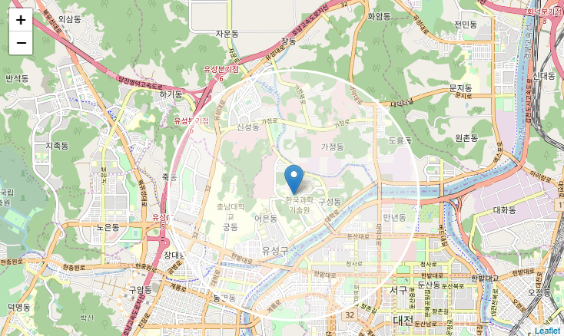

Get restaurant data from Foursquare. And label Chinese restaurant.

Red dots are Chinese restaurant and blue dots are other restaurant.

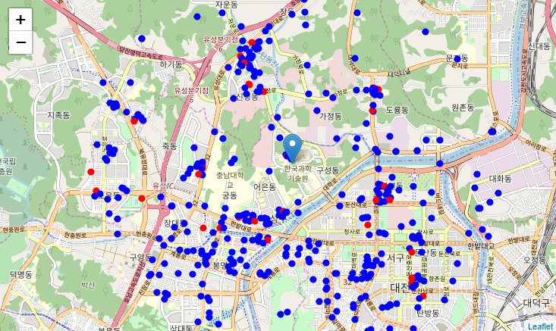

**Methodology**

1. We will use k-means to find clusters of hotels

2. Using visualization optimize clustering.

4. find center location of the clusters and number of hotels in the clusters

5. select important clusters

6. find best location for hotels based on the density from the clusters.

**Analysis**

**1. k-Means**

Use Elbow Method for Optimal k. From this we can find the best k is 5.

Fit clusters to data on k=5 using *KMeans* in *sklearn.cluster* and label the cluster information to data.

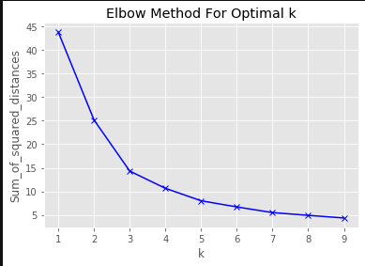

We can draw clusters on the map. Each clusters have different colors.

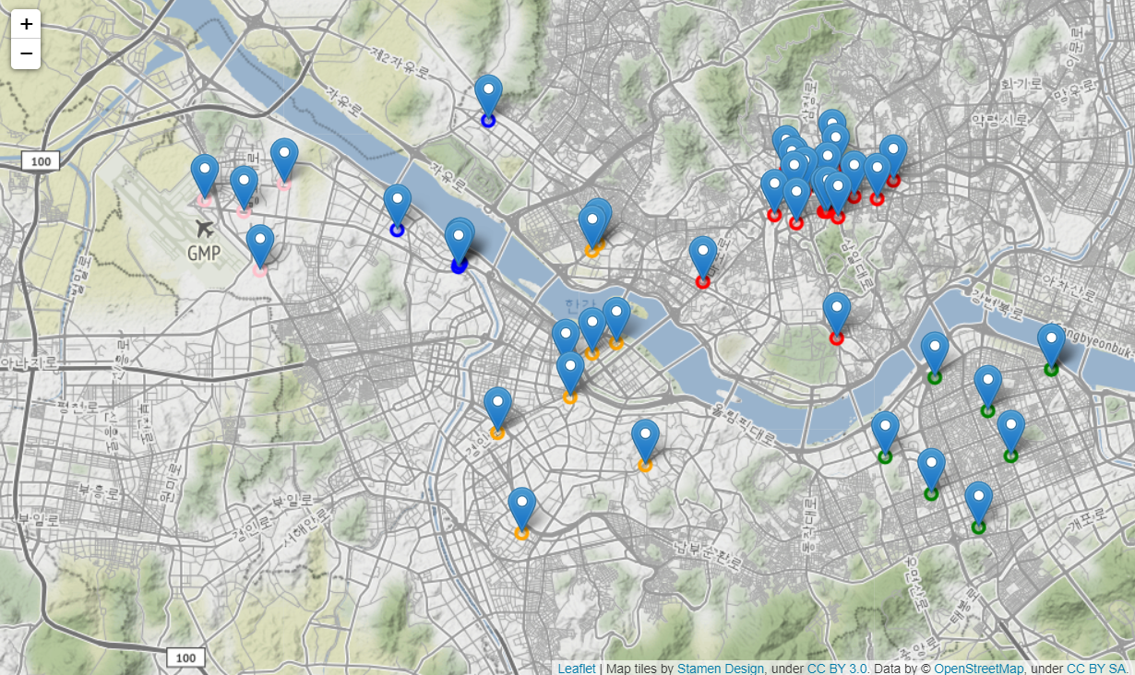

And we can find the number of hotels in each clusters.

number of hotels in cluster_0 : 19

number of hotels in cluster_1 : 5

number of hotels in cluster_2 : 9

number of hotels in cluster_3 : 9

number of hotels in cluster_4 : 4

From the location data of each clusters, we can get the information that there are many hotels in cluster_0.

We can get the mean of latitude and longitude of cluster_0

And that is **[37.562406, 126.984639] in black circle marker.**

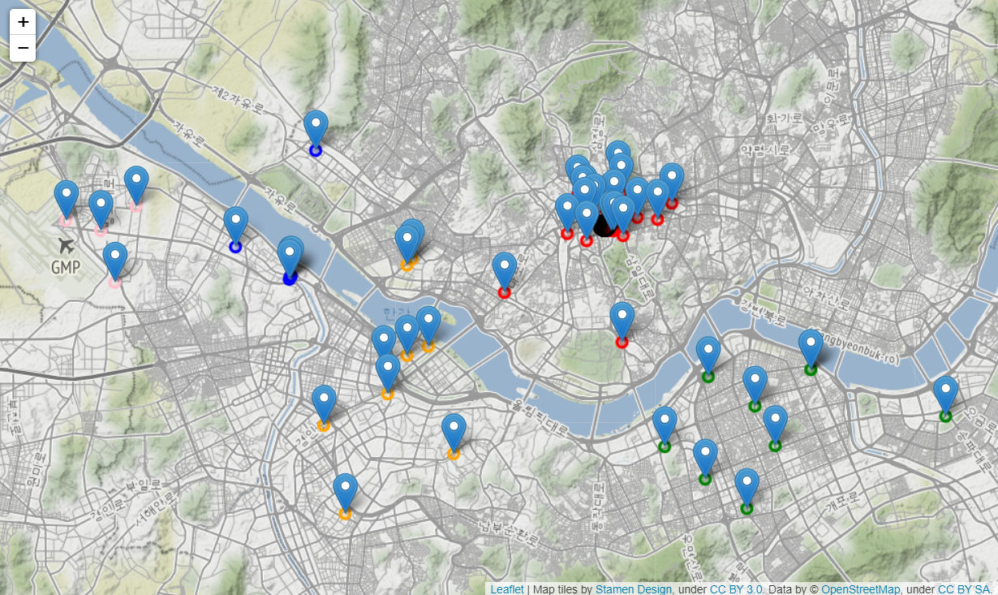

**Results and Discussion**

Results and Discussion From this Project we figure out places for the hotel in Seoul

From k-mean++ method, We can get the most dense and close coordinate is (lat : 37.562406, lng : 126.984639) So I will recommend if foriegners come to Korea, they can easily get the room of hotel in Seoul.

**Final Location : [37.562406, 126.984639][¶](https://dataplatform.cloud.ibm.com/data/notebooks/converter/assets/3ecb8049-6d37-4434-ac7b-c3daec01cc03?project=8b492406-a2b3-48d3-b33d-30c53017170c#Final-Location-:-[37.562406,-126.984639])**

**Conclusion**

From this project we figure out suitable place for the hotel based on each density.

We get data from Google API and Foursquare. From the data from Foursquare, we can get data of hotels around Seoul.

Using k-means, we find out the most dense hotel clusters around Seoul.

And count the number of hotels in the clusters to make sure the cluster is important for our project.

And the result is a little bit sorry to load more datasets of hotels in Seoul because of limitaion of free account. But, it true that from this project we get meaningful data for the business.

If we try to develop this project, we can consider about other data in real world.

**Thank you**